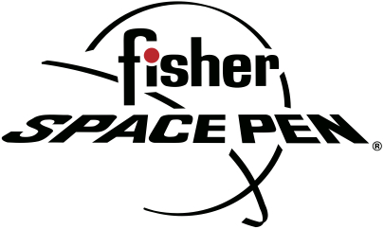

FISHER SPACE PEN
MATT FISHER, VICE PRESIDENT, SALES
BIOGRAPHY
Matt Fisher is Vice President of Sales at Fisher Space Pen Co., the iconic American family business based in Boulder City, Nevada, which was founded by his grandfather Paul C. Fisher, inventor of the original AG7 Anti-Gravity pen first used by American astronauts on Apollo 7 in 1968.
Matt began helping around the Fisher Space Pen factory at age 8. He worked there every summer until he was 16. He attended college and focused on a music career for a short while but decided to follow in his father’s footsteps, returning to work at Fisher Space Pen at age 21.
He began by working in every department of the family business for several months at a time in order to familiarize himself with the products and have a better understanding of operations. At 23, he began working in the Ad Specialties Division as a sales coordinator and became Director of Ad Specialties and Foreign Sales at 25. Last year, at age 28, Matt became Vice President of Sales.
Fisher Space Pen is a popular favorite among consumers of all ages. It is the most advanced and dependable writing utensil, which works in freezing cold and desert heat as well as underwater, upside down and in almost any climate or situation due to its hermetically sealed cartridge, which is pressurized with nitrogen and does not rely on gravity to work. The sleek, timeless pen, which is used in the International Space Station, is also in the Museum of Modern Art in New York City, acclaimed for its elegant industrial design. Fisher Space Pen is luxury at its finest. For more information: www.spacepen.com.
#####

